Start with this link
https://openweathermap.org/our-initiatives/student-initiative

Enter information similar to this
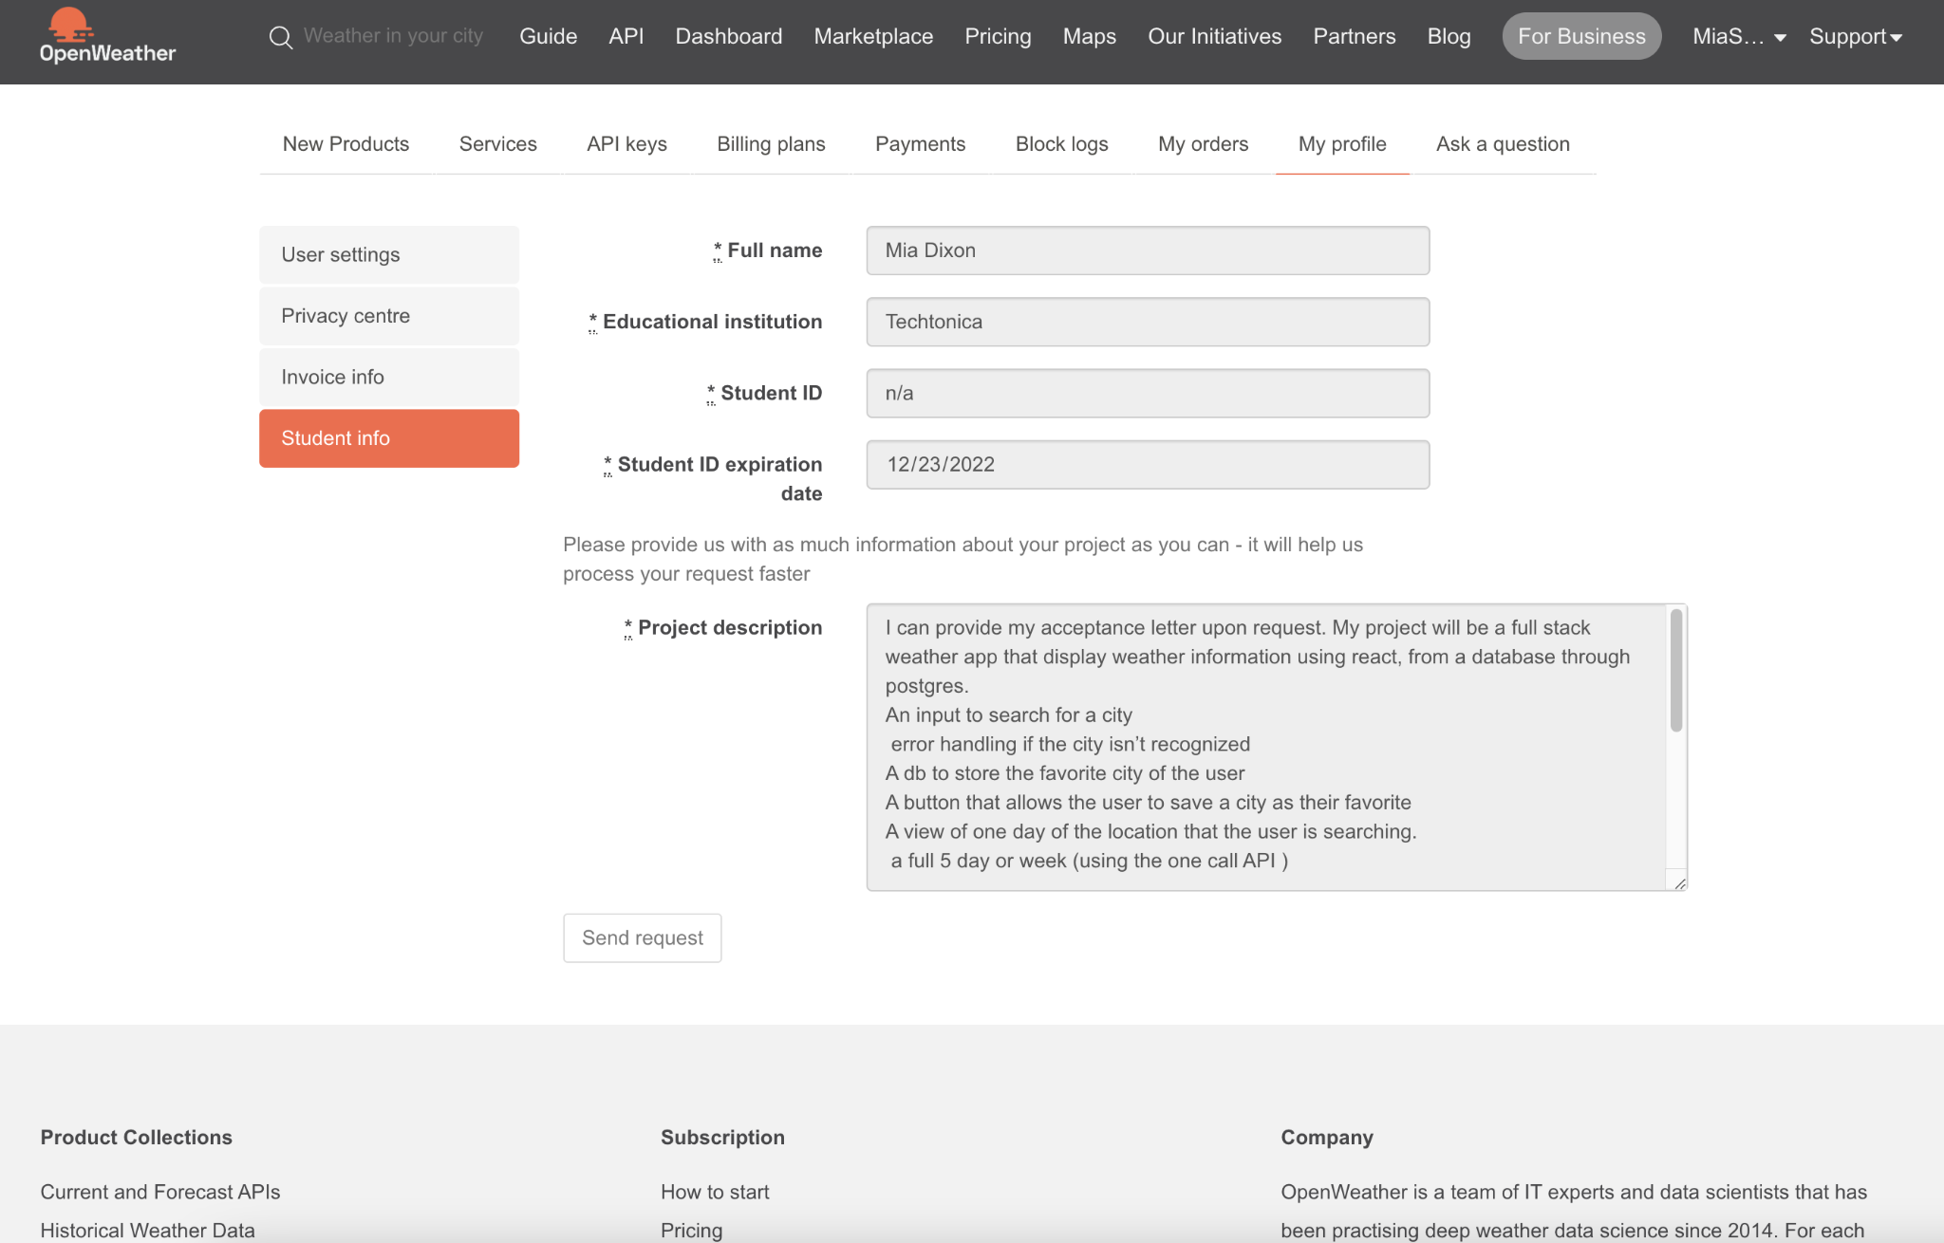
Expiration date is the end of the cohort
I copied the project description from the day doc for the project

You will then receive two emails similar to these:
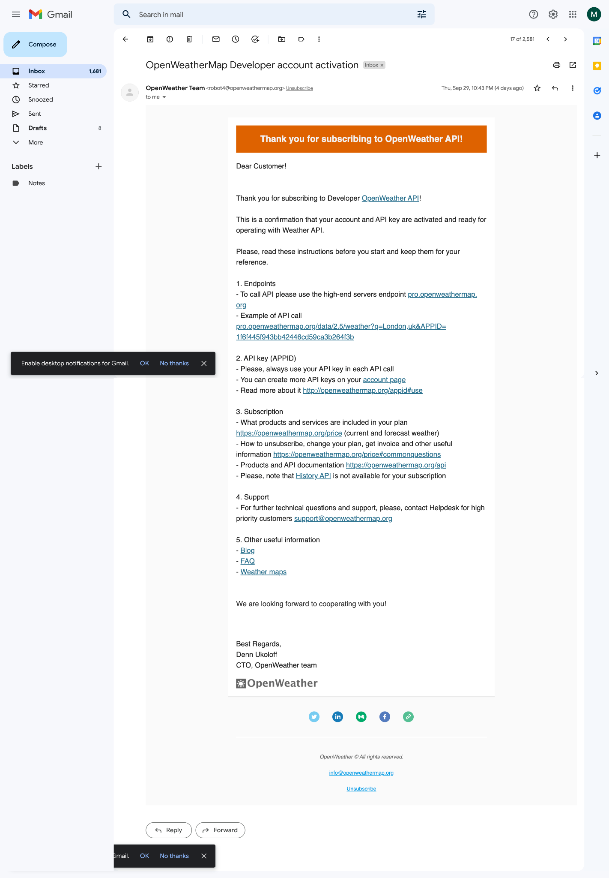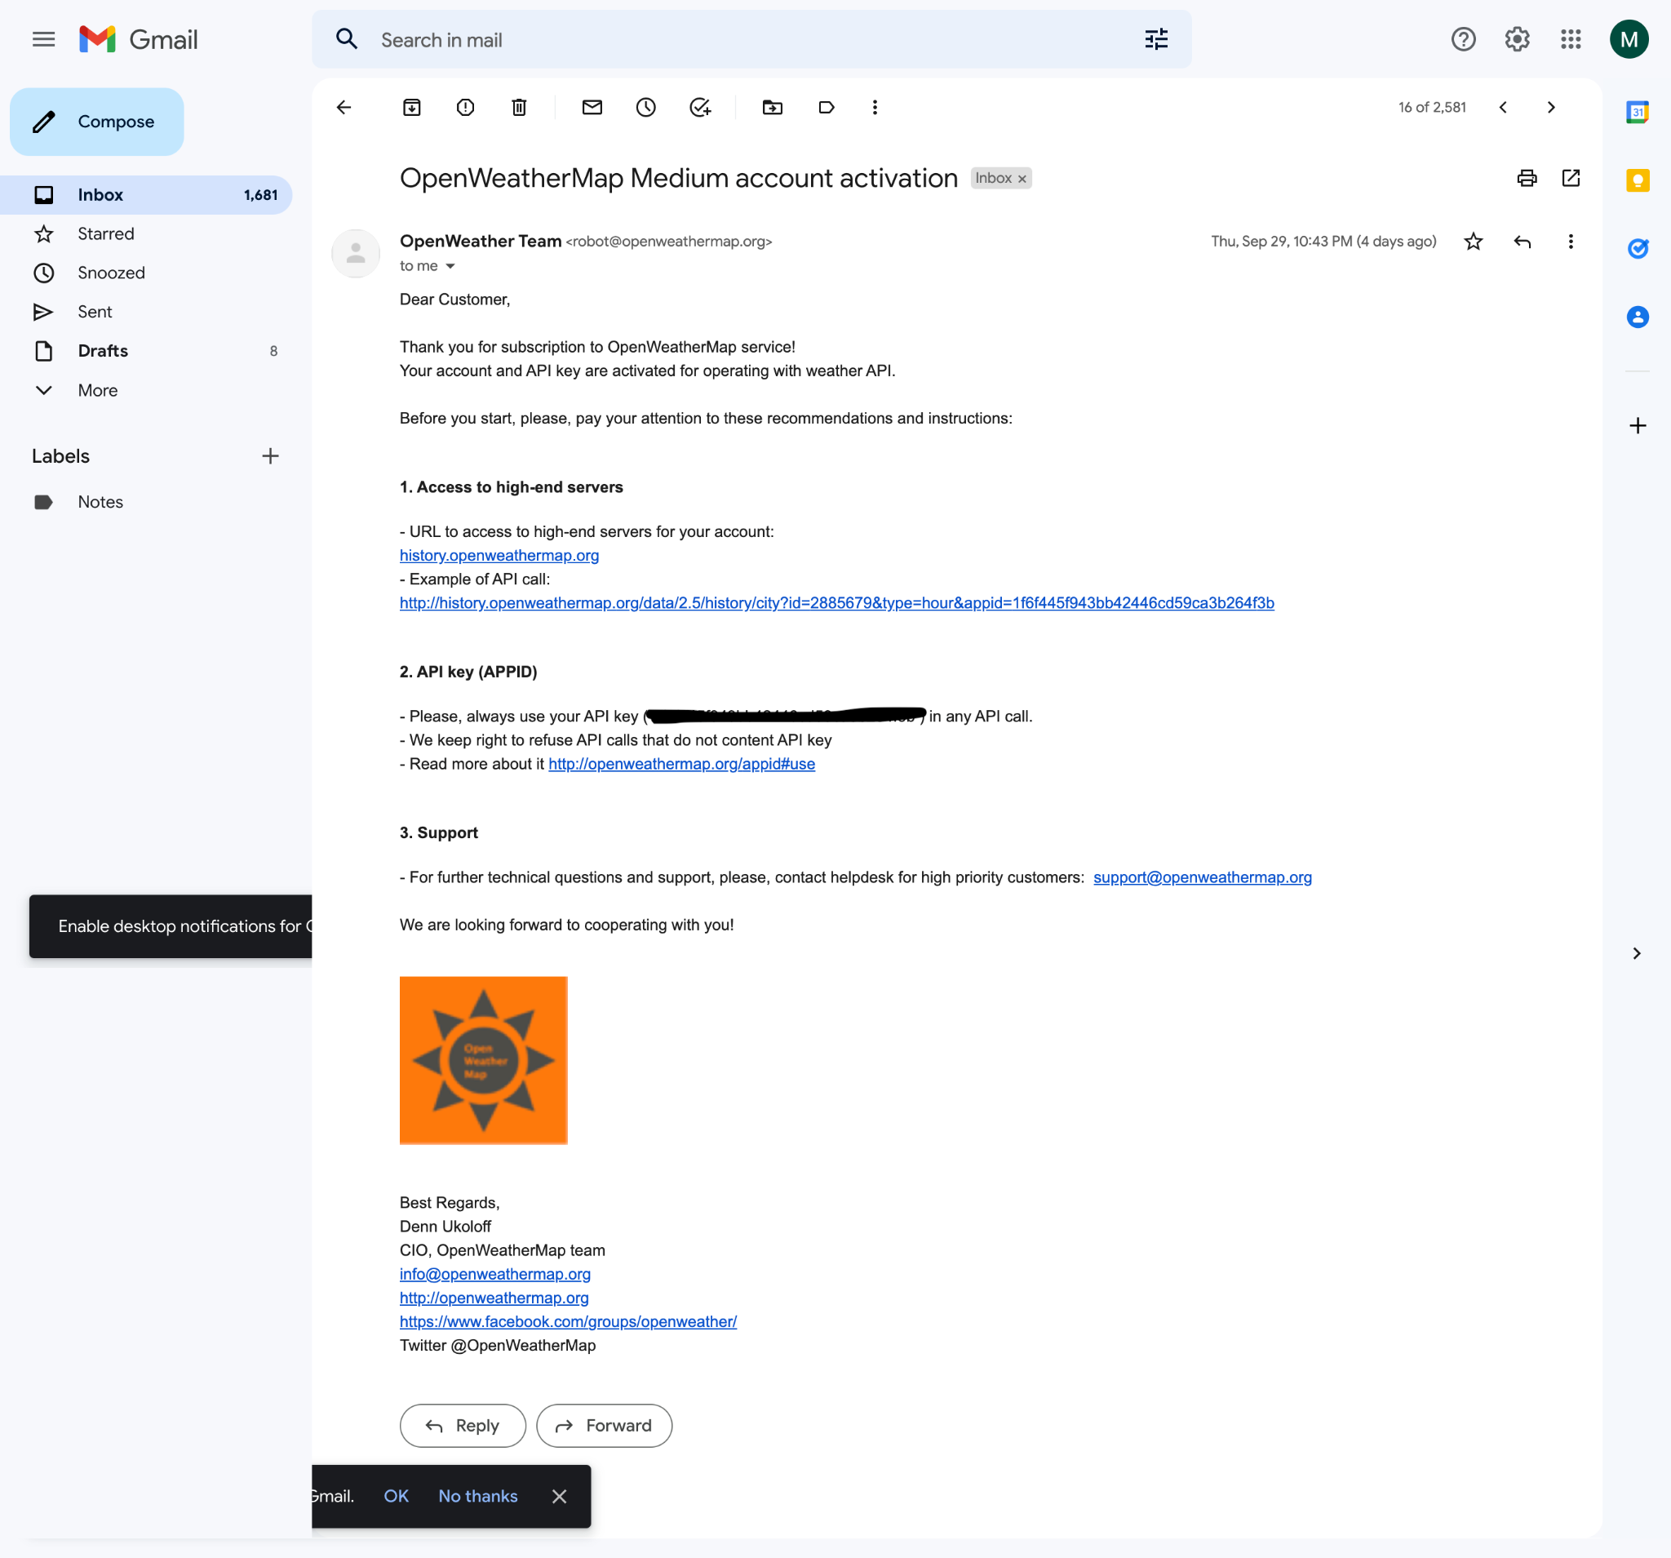

And finally, you can check if your account is active through your profile’s services page
